Path: Engineering -> EAR Proposal Dashboard
Screen Code: S0540

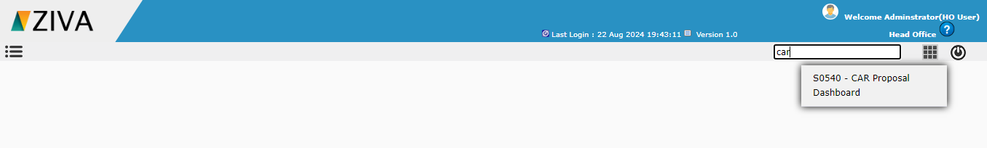

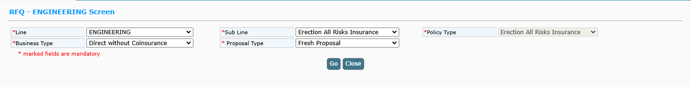
After selecting the sub Line and policy type details, on clicking Go button, remaining fields to capture the proposal details will be displayed.

In Contractor details, click on Add new Contract icon, user can able to create a new contract.
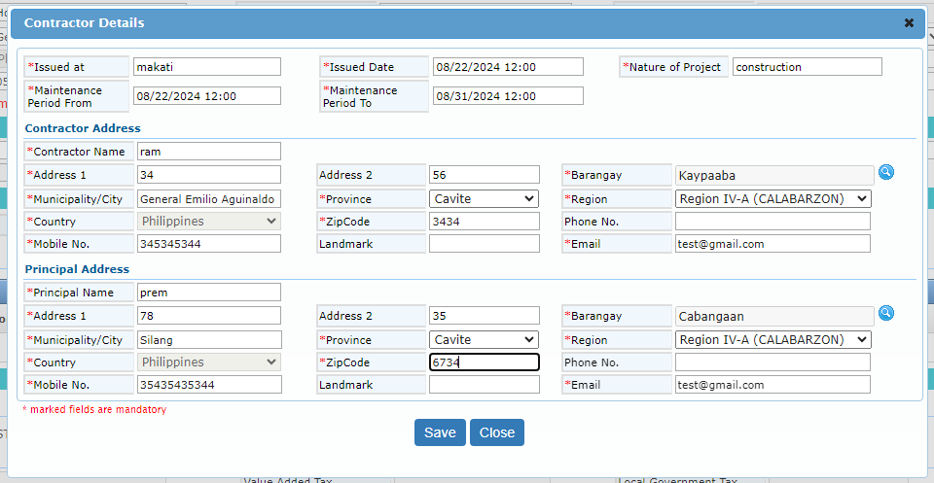
On clicking Save button, system add the contractor details. In the contractor details on clicking Sub Contractor icon, user can able to create multiple sub contractor.
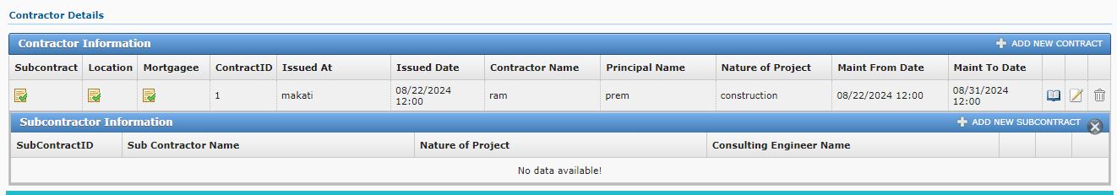
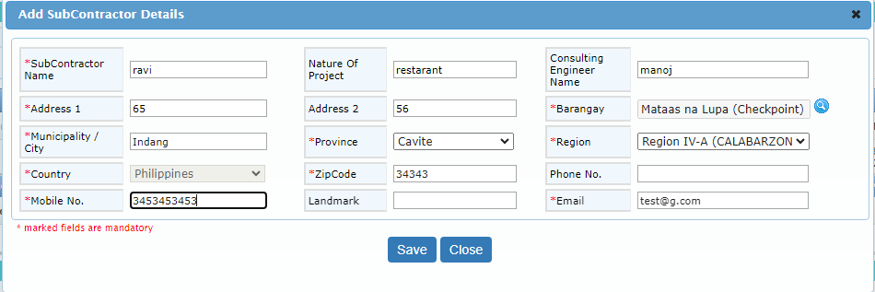

Click on Location icon to add the risk location details. Then enter the SMI and cover details for the respective location.

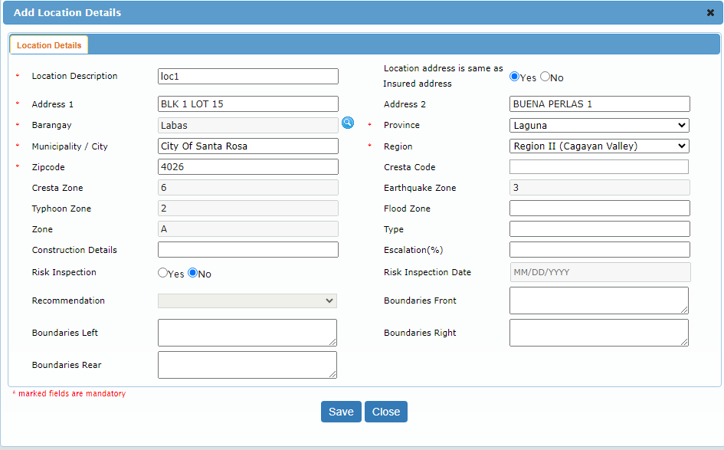

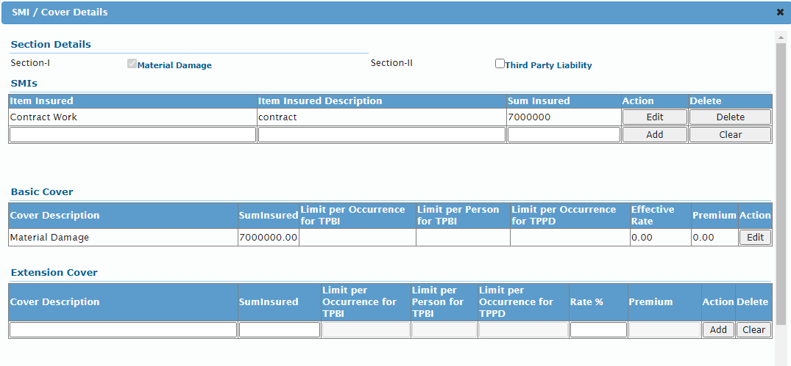
User can able to add the Mortgagee details for the location by clicking the mortgagee icon.

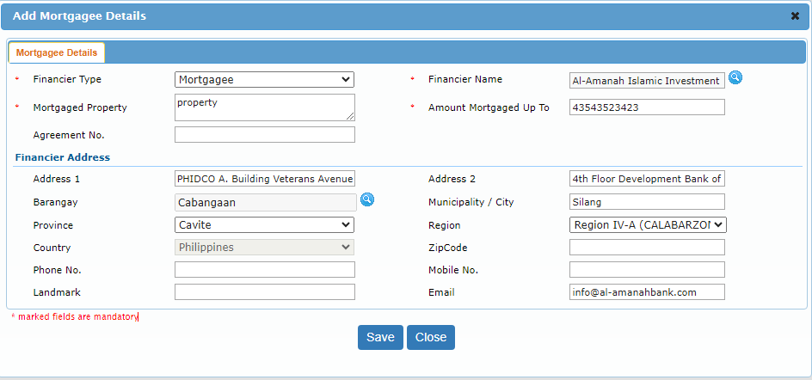

After entering all the details and click on calculate premium user can generate a RFQ number.

After entering all the details and click on calculate premium user can generate a Quote.

After generate a Quote , Generate Policy Button Enable.

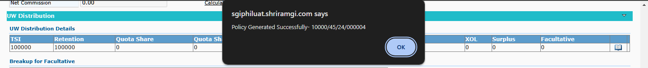

After click a Generate Policy Button, Policy will be Generated Successful.

